**Sharing Our Love of Sewing Through  
Workshops…  
 Suzy Furrer’s Moulage Class and several weeks afterwards perfecting fit  
social outings…  
our lunch at Breadwinners to “Beat the Heat”  
Always learning in our Neighborhood Groups…**

August 1 – Community Sew – String backpacks for homeless  
August 5 – We’re Sew Special – pizza party and planning  
August 6 – Couture – lining and underlining  
August 7 – Beaders Workshop – fieldtrip to Wild Beads, Arlington  
August 9 – TAG – sanitizer and tissue holders  
     NO sew-in for Community Sew  
August 11 – Material Girls – felting activities  
August 18 – Upping Your Game – sewing with bias  
August 19 – Hoopla Sisters – exploring zentangles  
August 26 – Designing Divas – drafting sleeves

Did you do any fabric purging this summer?   We need FABRIC! Our fabric sale supply is dwindling.  Please share with us a few pieces of fabric you are no longer interested in keeping.  Bring the fabric to a neighborhood group meeting, or contact Pam Walker at [donationsmanager@planoasgsews.org](mailto:donationsmanager@planoasgsews.org).   
   
**COMING UP ASG ZOOMS: You should get email notices soon**

August 21 – Joi Mahan on Pattern Talk - navigating through the current state of sewing pattern resources, availability,  
August 26 – Sew Sustainable Show and Tell  
September 29 – Done Is Better Than Perfect - keeping the joy in sewing  
   
Fall Events:  
October 3-5 - Plano ASG  In-town Retreat  
October 11 – Art Meets Fashion at Heard-Craig House, McKinney  
                                Early bird ticket sales now.

                   Go to [ART MEETS FASHION 2025 in McKinney - Checkout](https://www.ticketleap.events/tickets/heard-craig/art-meets-fashion-2025)  
   
October 18 – Plano ASG Fabric Sale (if we have enough fabric!)  
October 25, 11:30 a.m. – Plano ASG Luncheon/Annual Meeting

Suzy Furrer Workshop Pictures:  
  
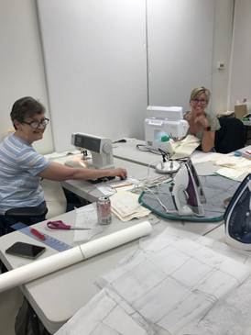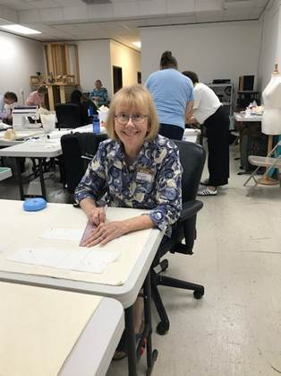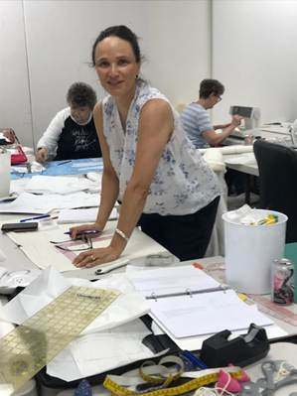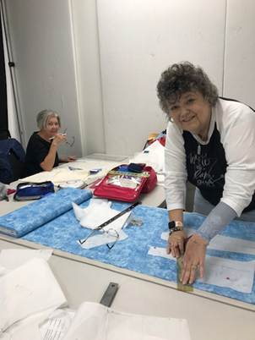  
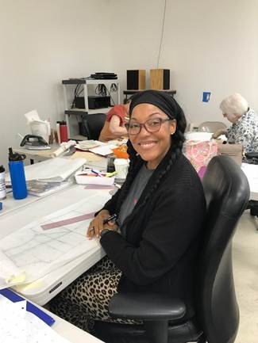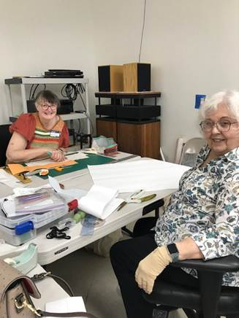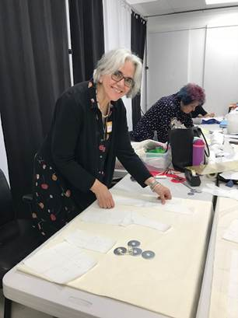  
  
  
   
  
  
  
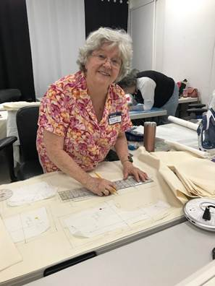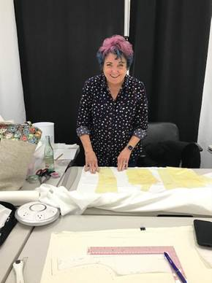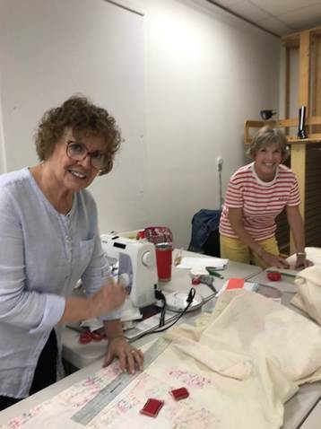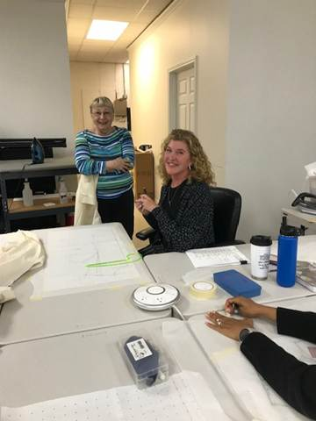  
 

“Beat the Heat” Lunch Pictures:  
